Louyoung Foundation /Jie Fa Gan Ji Tea Shop
Long/ Medium Time Volunteers (L/MTV)

Age : 20-40
Location: Xiluo Township, Yun-Lin County
Requirements: Application form
These positions are for 3-12 months.
Priority will be given to volunteers who can participate for 6 months.

-----------------------------------------------------------------------------------------------------------------------------------------------------

【Project Background】Xiluo Township

Xiluo, located in the middle of Taiwan the northest Township of Yunlin County, is situated in the Zhuoshui River alluvial fan valley which decrease progressively from the east to the south.
The great Xiluo Bridge is one of the most famous landmarks in Taiwan and has been standing on the River for 60 yearr. You can not only admire the beautiful sunset, but also enjoy the historical atmosphere and the typical Taiwanese culture in Xiluo old street.

During your stay in Xiluo, you can also learn traditional Chinese Kung Fu, experience Taiwanese Puppet show, Soy sauce making and organic vegetables farming. Moreover, the sculpture park is just nearby the great Xiluo bridge.

Night View Of The Xiluo Bridge | 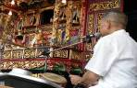  The Traditional Puppet Show & Musical | 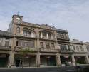  Yenping Historical Houses | 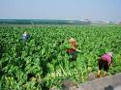  Countryside Farm

In 1895, Taiwan became a Japanese colony. Since Taiwan has a very rich and fertile soil, Japanese government increased Taiwan’s contribution to the Emperor of Japan. In order to achieve a complete colonization, Taiwanese education and culture were strictly regulated. In the 12th year of the Showa reign, a lot of public areas were repaired and reconstructed, including Yanping road, which was straightened and widened. Adding piers to Xiluo Bridge and maintaining the farmland, made Xiluo a modern and advanced agricultural town. The years of 1899–1940 are considered the golden age for its development.

We try to promote Xiluo’s culture and art in order to improve the quality of life, and to protect historical buildings and their identity
To improve the dynamic of the city, we would like to invite international friends to come join the social work. It is not only a voluntary work but also a great opportunity for cultural exchange
Participants will also have the opportunity to visit local artists, join local activities, experience ecotourism in their free days, exchange with local people and enjoy their warmth and friendliness.

【About the Xiluo street】
The current Yenping historical street extends from the eastern side of Datong road to the western part of Chonghsin road. In 1937, the street leader, Liao Chong-Guang, made plans to reorganize downtown Xiluo. He planned the city in a square-shaped area. Yenping road was widened by 15.5 meters with brick sidewalks on either side; trees were planted and power lines were installed to improve the comfort of its inhabitants.
At that time, architectural facades were removed, and buildings’ height were altered to make the street-widening process possible. During the 1925-1940 period, there were many styles visible on Yenping street with various unique architectural styles. Within a few years, the street was lengthened by 840 meters with the construction of many Western style buildings
Nowadays, there are 142 elegant houses remaining from this period. Most of them were built 90 years ago. Back in that time, Yenping Historical Street was the town center, a busy street fill with various traditional shops but now most of the houses are empty due to the departure of the shop owners. As a result, the economic activity of Yenping Street and its identity has gradually declined over the years.

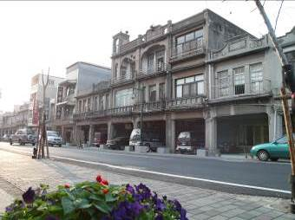 | 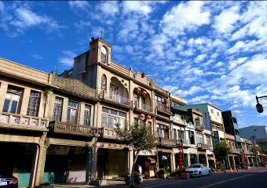 | 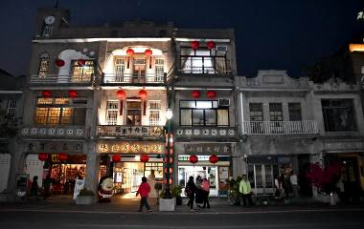 | 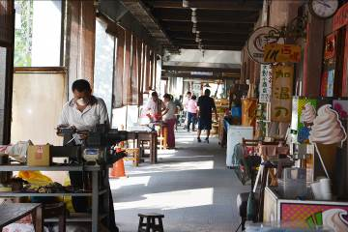

【Jie Fa Gan Ji Tea Shop】
Built by Hsu-Jing in 1932 at 90-92 Yenping Road, this double-wide historical building was once operated as a tea shop. Afterits owner passed away,the building was bequeathed to two different persons. Eventually, only the building number 92 was maintained in its old style as an antique tea shop. In addition to its extra width, the house also features a double street frontage. The front part was used as a tea shop, the middle, two-story part, was used as a factory; the third, three-story section featured an elegant hallway that made the home the finest in town.
Since 2002, this house has been maintained through volunteer work by the Louyoung Cultural and Educational Foundation as a Yenping Cultural Museum. Now, it is the most important cultural center in town, where young people’s talents are promoted and where visitors can learn about the old town’s history and construction.

【About The Foundation】
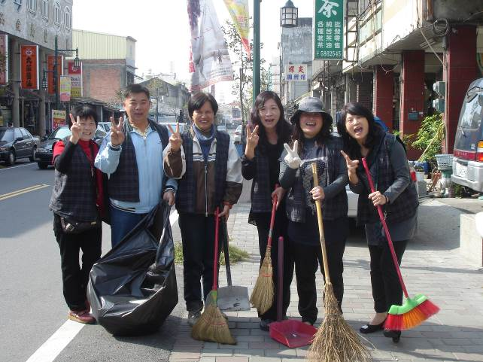
Louyoung Foundation was founded in 1995, by a group of enthusiastic local cultural figures, who first organised tour guide groups, volunteer groups, a scout community, the Louyoung puppet theater troupe, and much more.
The first preparations to establish Louyoung Cultural and Educational Foundation were made in 1994 by a group of like-minded friends who organized local concerts, art exhibitions, lectures and seminars to bring more activities into the community. The idea of a cultural center was also supported by local people who enjoyed the community activities and wanted to promote and maintain local traditions.
Luckily, preparations were made one year later, and in 1995 the first National Art Festival was launched in the county. Yunlin Cultural Bureau wanted to hold the festival in Xiluo, and in order to promote the local heritage, the festival was called “Romance of Xiluo”. Since at that time Louyoung Foundation was not known by Yunlin Cultural bureau, it officially applied to host the festival since this event will be a great opportunity to make Louyoung Foundation known to the public. Therefore, the initiative of inviting reporters and social media was taken in hope to promote the foundation and to raise enough funds to set it up.
As a result of the previous actions and initiatives, the Louyoung Cultural and Educational Foundation was founded. The board of directors was established, being led by: Chairman Liao Deng Tang and CEO Lee Hong Yi, followed by Lai Mei Ru and Louise Ho as Executive Secretaries, Liao Sheng Long, Yang Yong Xiong and the volunteer community hoping they could make Xiluo a better place.
The volunteers are also a very important part of the foundation, such as Zeng Si Bian, Guo Zhi Ming, Chen Yu Hui, Cheng Ruan, and Cheng Su Qin who still support the activities even now.
It is now the most important cultural center in the city, which provides space for artists and writers to display their work, and where visitors can learn more about the old town’s history and traditions. The Board of Directors and volunteers at Louyoung Foundation work hard every day to contribute with their time and money to protect Xiluo’s heritage and traditions.
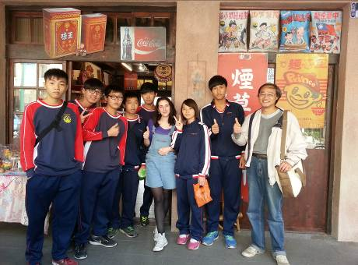 | 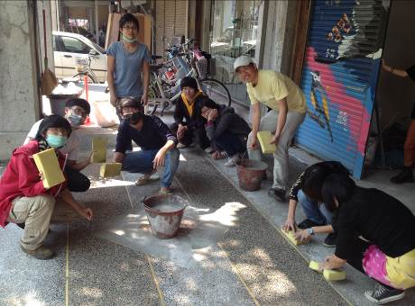 | 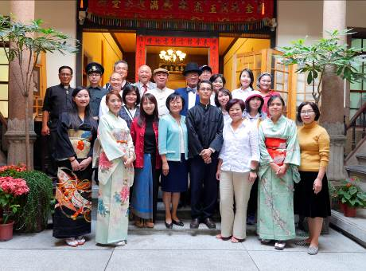

【About this Journey】
Today, walking along the Yenping Historical Street, you can see 142 decorated historical houses in total. Most of them were built more than 90 years ago. A century ago, Yenping Street was the “downtown” with prosperity, but nowadays, as business gradually declined, the residents moved away from Xiluo and Yenping Street have become quieter. As a result, many houses have started to decay.
Because of the "Community Renaissance" movement conducted by Luoyoung Foundation and local government, the street becomes prosperous again! In the past 9 years, we have invited many cultural groups and artists to visit and stay in Xiluo, and host different performances. We also hosted 11 international work camps focusing on renovating heritage houses.
We have made efforts to maintain the old houses but there are still a lot which need to be repaired. Therefore, we would like to invite international friends to come join us. It is not only a voluntary work but also a precious opportunity to experience different culture and widen your horizons.

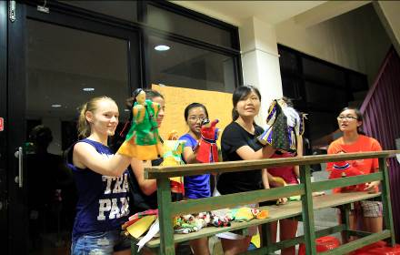 | 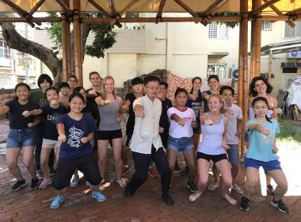 | 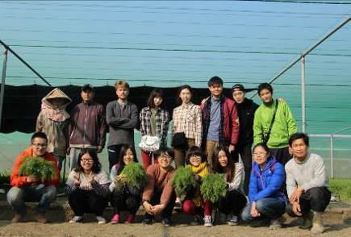

Aims
- Creating international cultural exchange and supporting the development of Xiluo community.
2) Revitalizing Xiluo historical street.
3) Making friends with global backpackers.
4) Improving Xiluo’s quality of life.

Type Of Voluntary Work :
Xiluo LMTV workcamp is going to assist Xiluo Cultural Museum(Louyoung foundation) and Be a Manager in Souvenirs shop. Volunteer need to do the daily house cleaning (or Souvenirs shop), help the foundation manage and update our social media, website, blog or Facebook. Volunteer has to maintain the backpacker house and Souvenirs shop with comfortable living conditions.
Volunteer will also do some gardening and join environmental community events etc…. Local volunteers will support international volunteer to run this project as well.

For more informations of Louyoung Cultural & Educational Foundation and international workcamps, please browse:
http://www.louyoung.org.tw
https://www.facebook.com/louyoung.ngo
https://www.facebook.com/siluo.yenping.museum/

Job description:
Work A: This is an international backpacker house and welcome people from all around the world. Therefore, volunteer has to be a kind host and will be in charge of daily maintenance and management (wash pillow case and blanket, clean the rooms). The volunteer will have to maintain the garden in the Louyoung foundation and it will be his/her duty to work in the reception.
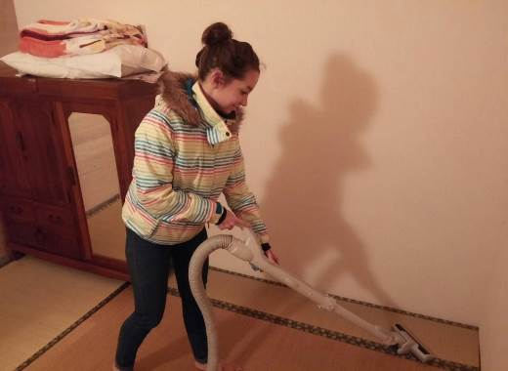 | 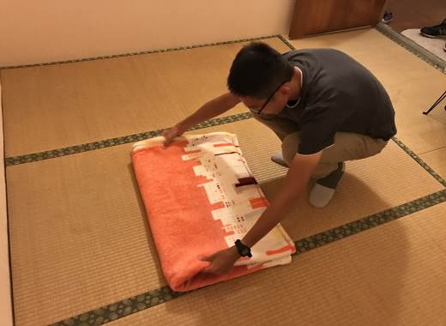

Work B: Volunteer that will run community shop will be in charge of the daily maintenance and management. He/she will also do some daily cleaning to keep the shop neat. The shop is run by the local volunteer team and they need international volunteer to support the daily operation. The shop sells some antiques, souvenirs and goods that are hand crafted here in Xiluo.
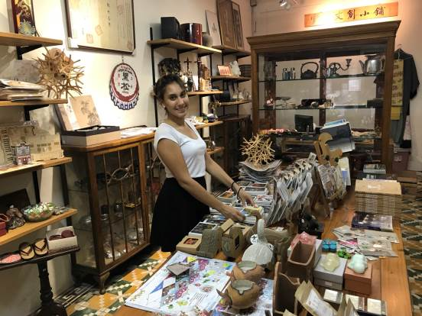 | 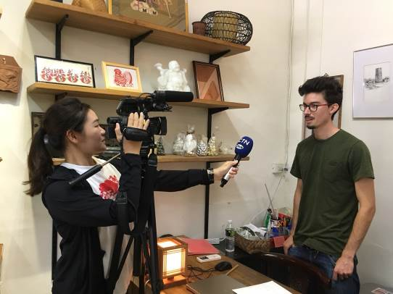
*If volunteers are interested in doing art works, he or she can tell us. We will financially support them by buying the material. If volunteers are interested, they will have the opportunity to participate in English teaching in schools.

Free Day: Volunteers will have 2 free days per week on Monday and Tuesday only. Weekend is always the busy day to run the backpacker house and Souvenirs shop. It is not allowed to take day off during the weekend.

Culture Exchange: The locals would be more than happy to welcome you in Xiluo. Please use this opportunity to exchange experiences, to learn more about other social, cultural and political living conditions and to show yours in return. In order to promote this, we will have some special cultural event and celebrations at the temple in September and October. The volunteers will be able to present their countries and have fun with the locals.

Weekly Schedule : We separate the work A and work B in the different way, 30-32 working hourrs per week, at least 2 free days per week. Volunteers can switch their duty and exchange work if needed.

Study theme : Participants are encouraged to share and to join the discussion of community development and share their view and opinion on their motherland.

Accommodation And Food : Accommodation is at 72ART . The address is: 2F, No.72 Yenping road, located in town center. Volunteer can use bike for daily transportation and bus station, post office or 24h shop are just nearby.
A comfortable blanket and pillow will be provided so there is no need to bring a sleeping bag. There will also be some allowance, around NT$ 5000, to support daily food. Volunteer can cook by themselves or enjoy the delicious local food in Xiluo restaurants.

* Internet is always available both in working place and accommodation.
* There is a washing machine in the accommodation.
* The weather changes a lot during the season, temperature could vary from 10℃ to 30℃, so please bring suitable clothes as well as an umbrella or a raining coat with you.

Location : A traditional and typical Taiwanese town in Yun-Lin County, locating on the middle-western of Taiwan. 1hr to Taichung city and 2hrs to Tainan city by public bus.

Google Map：64847雲林縣西螺鎮延平路92號(No. 92, Yanping Rd., Xiluo Township, Yunlin County 64847, Taiwan (R.O.C.)

Terminal (The closest big international airport) : Tao-Yuan international airport. Passengers need to transfer from Taipei, by KUO-KUANG Bus (國光客運) in Taipei Bus Station), to Xiluo Station. It takes 3 hours and a half from Taipei and costs around NTD$350.

Leisure Activities : Excursion, events organized by the foundation with local people, eco-tourism (optional),
etc.1hr to Taichung city and 2hrs to Tainan city by public bus.

Participation Fees : Free (Will provide accommodations). Volunteers should cover the
transportation and living expenses by themselves during free schedule.

Insurance :We only offer limited insurance to cover third party accident, please make sure you have an insurance
with you.

photos
Pictures were taken during the international workcamp from the last 2 years.
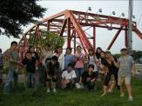  Volunteers At Xiluo Bridge |   Riding On The Xiluo Bridge | 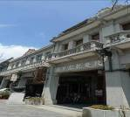  Louyoung Cultural & Educational Foundation | 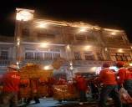  Xiluo Old Street
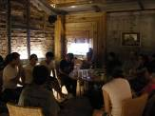  Great Night In The Historic House | 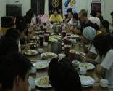  Volunteers Eating Together | 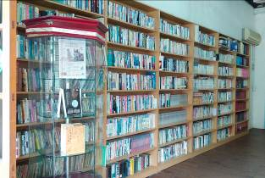  Community Library | 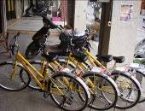  Your Transportation-Bike
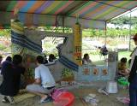 Doing Artwork | 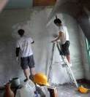  Paintwork | 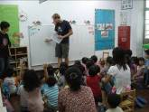  English Teaching | 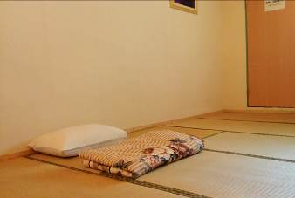  Backpacker House
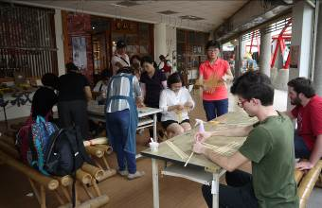  Learning Handcraft | 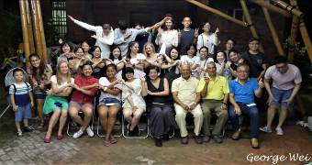  Having fun In Xiluo | 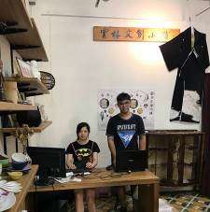  Souvenirs Shop | 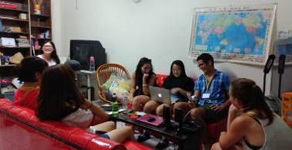  Living Room In The Accommodation
Volunteer Application Form

申請人  Name of Artist (or Group) |  | 國籍  Citizenship | Nationality:  City:
性別  Sex | □男Male □女Female
身分證字號  Passport No. |  | 出生年月日  Date of Birth | (D) (M) (Y)
停留時間  Projet Day | / / (D/M/Y) to / / (D/M/Y)
通訊處
Mailing Address
電話  Telephone | Cell Phone:  Home:
E-mail
語言  Language | Mother Tongue:____________  1._______________ □Fluent □Good □Basic  2._______________ □Fluent □Good □Basic
學歷  Education | *Please specify the school, department, degree, program, etc.
經歷Experience/ Curriculum vitae | *Please specify your experience or any experience in volunteering, even locally?
個人網站連結  Links | Websites:  FB:  Others:
緊急聯絡人  Emergency Contact Information | Name:  Relationship with Applicant:  Telephone:  E-mail:
動機  motivation | Why you have chosen this project and this type of work?
計畫期待  expect | What do you expect from it?
資訊來源  Source of information | How have you got to know louyoung foundation ?  1: FB/ 2: Website/ 3: Friends/ 4: Media & book/ 5: Seminar & event/ 6: Others

